~Software and hardware tools:
- Install Wireshark on your laptop and capture 2 minutes of network traffic while you browse Instagram or YouTube; save the capture as a .pcap file and note the top 3 protocols you see.
Steps:
- Open Wireshark.
- Select your active Wi-Fi or Ethernet interface.
- Click the Start Capture (blue shark fin) button.
- Browse Instagram or YouTube for about 2 minutes.
- Click Stop Capture (red square).
- Save the file as network_capture.pcapng (or .pcap if required).
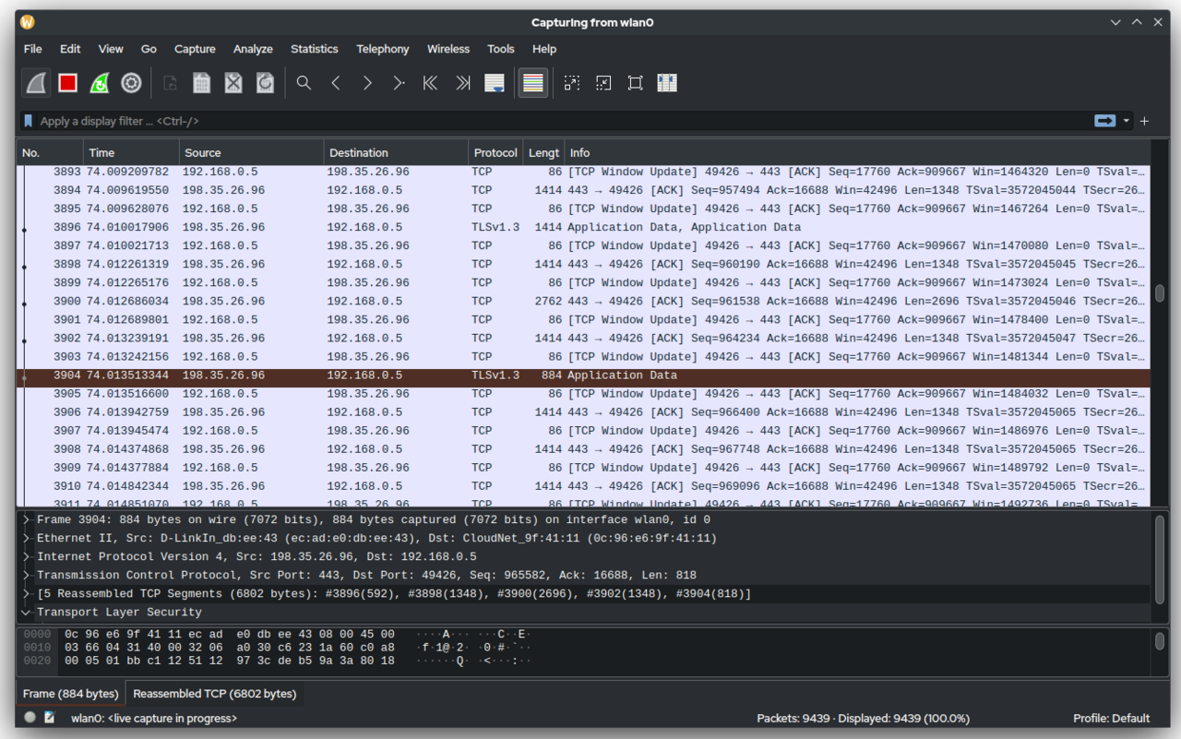
Typical Top 3 Protocols:
Protocol | Purpose
TCP | Reliable transport of web data.
TLSv1.2 / TLSv1.3 | Encrypts communication with websites like Instagram and YouTube (HTTPS).
DNS | Resolves domain names (e.g., www.youtube.com) into IP addresses.
Sample Observation
- Capture Duration: 2 minutes
- Top Protocols Observed:
  - TCP
  - TLSv1.3
  - DNS

- Use the 'ping' command in Command Prompt or Terminal to test connectivity to www.spotify.com and www.zomato.com; record the response times and identify which site responds faster.
ping www.spotify.com

Pinging atc.spotify.map.fastly.net [2a04:4e42:31::810] with 32 bytes of data:
Reply from 2a04:4e42:31::810: time=67ms
Reply from 2a04:4e42:31::810: time=100ms
Reply from 2a04:4e42:31::810: time=105ms
Reply from 2a04:4e42:31::810: time=89ms

ping www.zomato.com

Pinging e70929.dsca.akamaiedge.net [2600:140f:7200:49::17d4:65] with 32 bytes of data:
Reply from 2600:140f:7200:49::17d4:65: time=65ms
Reply from 2600:140f:7200:49::17d4:65: time=66ms
Reply from 2600:140f:7200:49::17d4:65: time=59ms
Reply from 2600:140f:7200:49::17d4:65: time=57ms

- Open Task Manager (Windows) or Activity Monitor (Mac) and list all running processes related to Chrome, WhatsApp Desktop, or any browser-based app you use; note the process name and memory usage for each

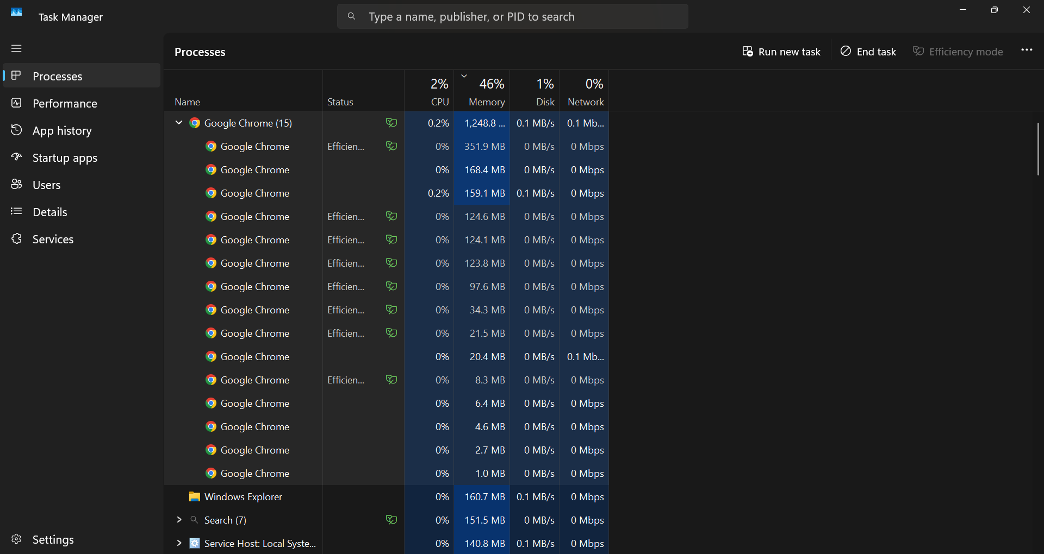
Steps (Windows):
- Press Ctrl + Shift + Esc to open Task Manager.
- Click the Processes tab.
- Find Google Chrome, WhatsApp, or your browser.
- Expand the application to see all related processes.
- Note the Process Name and Memory usage.
Example Table:
Process Name | Memory Usage (Example)
Google Chrome | 320 MB
Google Chrome (Renderer) | 180 MB
Google Chrome (GPU Process) | 95 MB
Google Chrome (Utility) | 45 MB
WhatsApp | 210 MB
Note: These values are only examples. Your Task Manager will show different process names and memory usage depending on what is running on your computer. Use your own readings for the assignment.

- Download and run the free version of 'Angry IP Scanner' or 'Advanced IP Scanner' to scan your local WiFi network; list the IP and device name of at least 2 devices connected to your network.<br><br><em><strong>Hint:</strong> Make sure your firewall allows scanning, and only scan your own home/college network.</em>
Steps:
- Download and install Angry IP Scanner or Advanced IP Scanner.
- Connect to your home or college Wi-Fi.
- Open the scanner.
- Set the scan range (e.g., 192.168.1.1 to 192.168.1.254).
- Click Scan.
- Note at least two discovered devices.

Example Result (Format Only):
IP Address | Device Name
192.168.1.1 | Home Router
192.168.1.105 | Manthan-Laptop
Use the actual IP addresses and device names shown by the scanner on your network for your assignment, not the example above.

- Use ChatGPT or Bing AI to suggest 3 hardware tools (like cable tester, crimping tool, or multimeter) used in network troubleshooting; for each, write one line describing when you would use it.

Hardware Tool: | When You Would Use It
Cable Tester- | Used to check whether an Ethernet cable is wired correctly or has faults such as broken pairs.
RJ-45 Crimping Tool- | Used to attach RJ-45 connectors to Ethernet cables when making or repairing network cables.
Digital Multimeter- | Used to measure voltage, continuity, and resistance when troubleshooting power or network hardware issues.

THE END……

